**ELEC2040 Practice Quiz**

**Q1** Let , and  find:

1. 
2. 
3. Write  in exponential form (i.e. ). Find and .
4. Find  (express in the form  - Cartesian form). Find and .
5. Write  in terms of and  (from part (c)).
6. Find 
7. Find  in exponential form
8. Find  in Cartesian form
9. Find  in exponential form
10. Find 

**Q2**

Let , and let  be the complex conjugate of .



Show that



can be written in the form

for some real constants  and .

Find  and .

**Useful Trigonometric formulae**



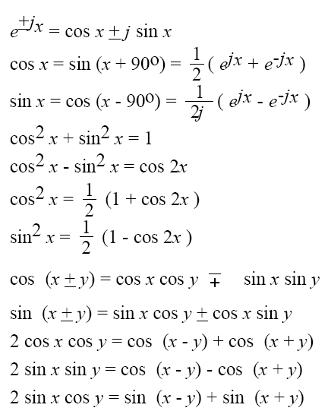

**End of test paper**